EXPT NO:2 | Implementation of data visualization techniques
DATE: 06.01.2026 | Implementation of data visualization techniques

PRE-LAB QUESTIONS (PROVIDE BRIEF ANSWERS TO THE FOLLOWING QUESTIONS)
- Why is exploratory data analysis critical before model building?
Exploratory Data Analysis is crucial for understanding the overall structure, quality, and characteristics of a dataset before model development. It helps identify patterns, trends, correlations, and variations that influence model behavior. EDA also assists in detecting missing values, inconsistencies, and noise in the data. This process ensures proper data preprocessing and significantly improves model reliability and performance.
- How do distributions influence algorithm selection in ML?
Data distributions determine how learning algorithms interpret and process input features. Some algorithms perform optimally when data follows specific distribution assumptions, while others are more flexible. Understanding the distribution helps in selecting algorithms that handle skewness, variance, and scale effectively. This leads to improved prediction accuracy and stable learning outcomes.
- What insights can outliers provide in business data?
Outliers represent data points that significantly deviate from the normal range of values. They may indicate abnormal behavior, exceptional events, or underlying data quality issues. Analyzing outliers helps organizations identify potential risks and unusual trends. This supports better monitoring, decision-making, and strategic planning.
- Why are visual summaries preferred over raw tables?
Visual summaries present complex and large datasets in a simplified and intuitive format. They allow faster identification of trends, patterns, and variations within the data. Raw tables require extensive effort to interpret and analyze. Visualization improves clarity, understanding, and analytical efficiency.
- How does visualization improve business intelligence?
Visualization transforms raw data into actionable and meaningful insights. It highlights important trends, patterns, and anomalies effectively. Decision-makers can interpret information quickly and communicate insights clearly. This leads to improved strategic, operational, and data-driven business decisions.
IN-LAB EXERCISE:
OBJECTIVE:
To explore data distribution and variability using advanced visualization techniques.
SCENARIO:
A startup analyzes e-commerce transaction data to understand customer spending behavior and detect abnormal purchase patterns.

IN-LAB TASKS (Using R Language)
- Plot histogram of transaction amounts
- Use boxplot to detect outliers
- Create heatmap of monthly sales intensity

(CODE: CONATAINS STUDENT ROLL NOS
SCREENSHOT OF CODE
SCREENSHOT OF OUTPUT)

Code:

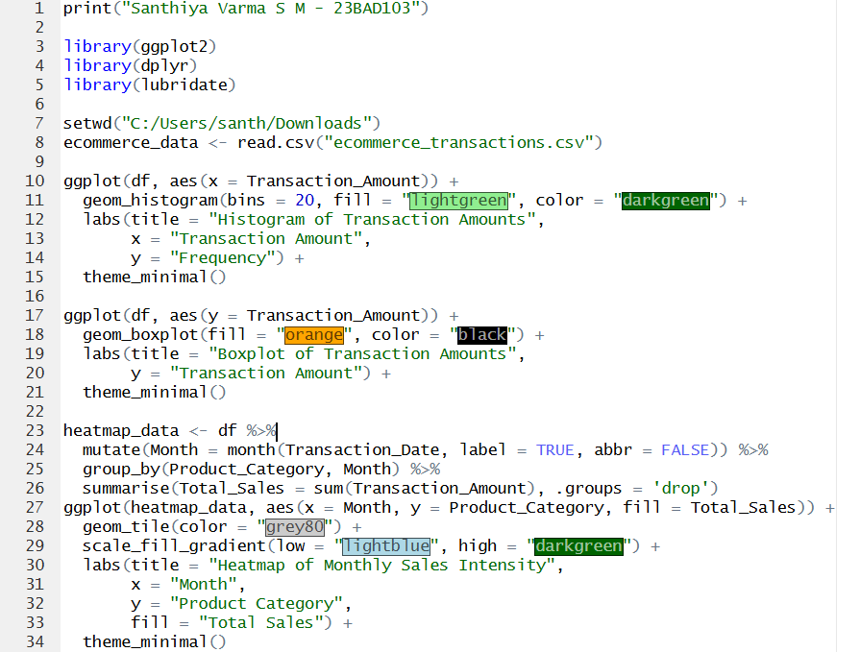

Output:


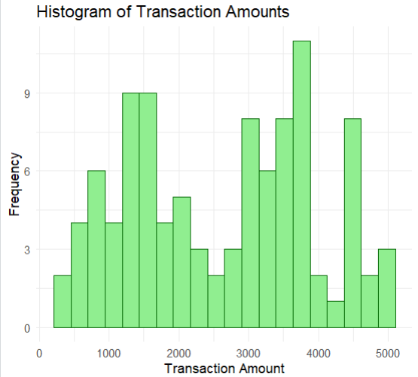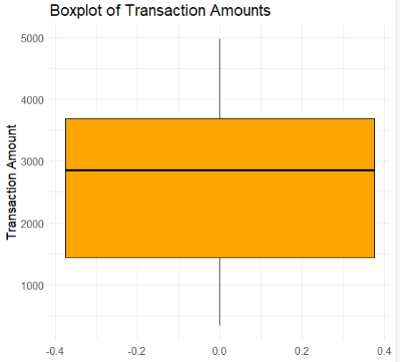
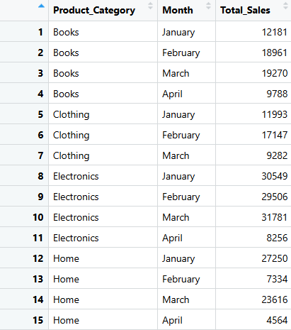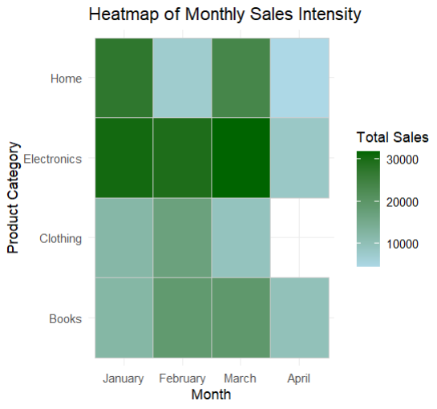

POST-LAB QUESTIONS (PROVIDE BRIEF ANSWERS TO THE FOLLOWING QUESTIONS)
- What does right-skewed distribution indicate about customer behavior?

A right-skewed distribution indicates that most values are concentrated toward the lower range. A smaller proportion of values extend toward higher levels. This shows an uneven distribution within the dataset. Such behavior reflects variability and imbalance in spending patterns.

- How can detected outliers impact business decisions?

Detected outliers reveal abnormal or unexpected data points within the dataset. They may indicate potential risks, unusual activities, or rare conditions. Identifying these values helps organizations improve control and monitoring mechanisms. This enables informed, preventive, and corrective business decisions.

- Which visualization best supports anomaly detection?

Boxplots are highly effective for identifying anomalies in data. They clearly display the spread, median, and extreme values. Outliers are visually separated from normal observations. This makes boxplots a suitable tool for anomaly detection.

- How does EDA improve AI model accuracy?

EDA improves AI model accuracy by ensuring clean, consistent, and well-structured data. It helps detect irregular patterns, noise, and inconsistencies early in the process. Proper preprocessing enhances the learning capability of models. This results in more accurate, reliable, and robust AI systems.

- How can visualization guide feature engineering?

Visualization helps uncover important relationships and dependencies within the data. It reveals patterns that may not be easily visible in raw datasets. These insights support the selection and creation of meaningful features. Effective feature engineering significantly improves model performance.

ASSESSMENT
Description | Max Marks | Marks Awarded
Pre Lab Exercise | 5
In Lab Exercise | 10
Post Lab Exercise | 5
Viva | 10
Total | 30
Faculty Signature

